NIGER DELTA UNIVERSITY

WILBERFORCE ISLAND, AMASSOMA  
BAYEL SASTATE

FACULTY OF SCIENCE

DEPARTMENT OF COMPUTER SCIENCE

ASSIGNMENT3

COURSE TITLE: ALGORITHM

COURSE CODE: CMP421

COURSE LECTURER: DR KENEKAYORO

NAME:

AKPOBI BENEDICT OGHENEVWEGBA

MATRICNO.:

UG/17/0041

FACULTY OF ENGINEERING  
DEPARTMENT OF MECHANINAL ENGINEERING  
Representation of courses in the department of Mechanical Engineering,  
Faculty of Engineering as a graph.

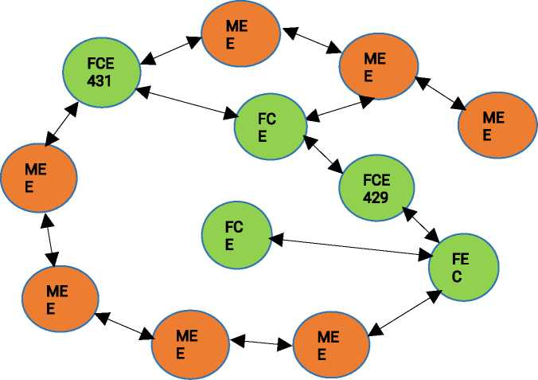

MECHANINAL ENGINEERING COURSES (400L)

* Heat and Mass transfer (MEE 421)
* Metalluray II (MEE45))
* Fluid power Syytem (MEE 43))
* Instramentatinn and measurement tMEE 481)
* Autamobilu Engineering (MEE 493)
* Thermodynamics III (MEE 423)
* Engineering practice and presentatinn (FCE 41))
* FCE 43) (Forrowed courses)
* FCE 432
* FCE 482
* FCE 40)
* FCE 429